CARLETON UNIVERSITY

SYSC 5104
METHODOLOGIES FOR DISCRETE EVENT MODELING AND SIMULATION

Fall 2008
Instructor: Prof. Gabriel A. Wainer

Assignment # 2

Prepared by: Ahmed Sayed Ahmed
Student Number: 784 206
Email: asahmed@sce.carleton.ca

Urban Simulation Using Neural Networks and Cellular Automata
For Land Use Planning

System Description

A real city, Dongguan, was selected for the experiment to demonstrate the advantages of the neural-network-based CA model. The model was used to simulate the conversion from non-urban land use to urban land use. Located in the Pearl River Delta region, China, it has a total land area of 2,465 km2. It is a fast growing region with a tremendous amount of land use changes.

The concept is simple: a population is defined as 3 dimensional arrays of 9x18 cellular cells in each layer as follows:
- Layer 1: with a value representing “1” if the cell is populated, and “0” if there is no population in the cell. Layer 1 is shown in Fig.1.

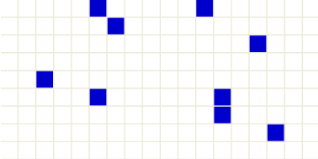
Figure 1. Layer 1 for initial population
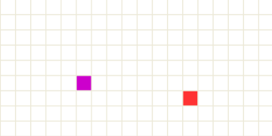
- Layer 2: with a value representing “3” if the cell is occupied by city, "2" if the cell is occupied by town, and “0” if there are no cities or towns in the cell. Layer 2 is shown in Fig.2.
City Cell
Town Cell
Figure 2. Layer 2 for initial pos of cities and towns

- Layer 3: represents the output of running population with a value representing “3” if the cell is populated due to the influence of city, "2" if the cell is populated due to the influence of town, and “0” if there is no population. Layer 3 is shown in Fig.3.

Figure 3. Layer 3 is empty befor simulation.
The system is divided into two zones:
- Zone 1 assigned to layer 1 and applied rule on it is Source.
- Zone 2 assigned to layer 3 and applied rule on it is PopRule.

Formal Specification
The following is the formal specification for the Cell-DEVS Population model:

CD = < X, Y, I, S, θ, N, d, δint, δext, τ, λ, D >
X = Ø
Y = Ø
S = {0, 1, 2, 3}
N = neighborhood = {(-2,0,-1), (-1,0,-1), (0,0,-1), (-2,-1,-1), (-1,-1,-1), (-2,-2,-1), (-1,-2,-1),
(-2,1,-1), (-1,1,-1), (-2,2,-1), (-1,2,-1), (2,0,-1), (1,0,-1), (2,-1,-1), (1,-1,-1), (2,-2,-1), (1,-2,-1),
(2,1,-1), (1,1,-1), (2,2,-1), (1,2,-1), (0,1,-1), (0,2,-1), (0,-1,-1), (0,-2,-1), (-2,0,1), (-1,0,1), (0,0,1),
(-2,-1,1), (-1,-1,1), (-2,-2,1), (-1,-2,1), (-2,1,1), (-1,1,1), (-2,2,1), (-1,2,1), (2,0,1), (1,0,1), (2,-1,1),
(1,-1,1), (2,-2,1), (1,-2,1), (2,1,1), (1,1,1), (2,2,1), (1,2,1), (0,1,1), (0,2,1), (0,-1,1), (0,-2,1),
(0,0,-2), (-1,0,0), (-1,1,0), (-1,-1,0), (0,1,0), (0,-1,0), (1,0,0), (1,1,0), (1,-1,0), (0,0,0)}
d = 1000 ms
τ: NàS:
S = 3 if cell (0, 0, 0) = 1 and any city neighbors = 3
S = 2 if cell (0, 0, 0) = 1 and any town neighbors = 2
S = 1 if cell (0, 0, 0) = 1

For the model’s specifications shown in Population.ma
- Layer 1 after simulation
Value:
0 represents an empty cell
1 represents that there is population in that cell
- Layer 2 after simulation
Value:
2 represents that there is town in that cell
3 represents that there is city in that cell
- Layer 3 after simulation
Value:
0 represents an empty cell
1, 2, 3 represents that there is population in that cell

Implementing and Testing
The simplified rules that defined in the model are done in the first and third layers as follows:
[Source] % for the first layer
%movement rules for people
rule : 1 1000 {(0,0,0)=0 and (((-1,0,0)=1 or (-1,1,0)=1 or (-1,-1,0)=1 or (0,1,0)=1 or (0,-1,0)=1 or (1,0,0)=1 or (1,1,0)=1 or (1,-1,0)=1) and ((-2,0,1)=2 or (-1,0,1)=2 or (0,0,1)=2 or (-2,-1,1)=2
or(-1,-1,1)=2 or (-2,-2,1)=2 or (-1,-2,1)=2 or (-2,1,1)=2 or (-1,1,1)=2 or (-2,2,1)=2 or (-1,2,1)=2 or (2,0,1)=2 or (1,0,1)=2 or (2,-1,1)=2 or (1,-1,1)=2 or (2,-2,1)=2 or (1,-2,1)=2 or (2,1,1)=2 or (1,1,1)=2 or (2,2,1)=2 or (1,2,1)=2 or(0,1,1)=2 or(0,2,1)=2 or (0,-1,1)=2 or(0,-2,1)=2))}

rule : 1 1000 {(0,0,0)=0 and (((-1,0,0)=1 or (-1,1,0)=1 or (-1,-1,0)=1 or (0,1,0)=1 or (0,-1,0)=1 or (1,0,0)=1or (1,1,0)=1 or (1,-1,0)=1) and ((-1,0,1)= 3 or (0,0,1)= 3 or (-1,-1,1)= 3 or (-1,1,1)= 3 or (1,0,1)= 3 or (1,-1,1)= 3 or (1,1,1)= 3 or(0,1,1)= 3 or (0,-1,1)= 3))}

rule : {(0,0,0)} 100 {t}

[PopRule] % for the third layer
%movement rules for people
rule : 1 1000 {(0,0,0)=0 and ((0,0,-2)>= 1)}

rule : 2 1000 {(0,0,0)>=0 and ((-2,0,-1)= 2 or (-1,0,-1)= 2 or (0,0,-1)= 2 or (-2,-1,-1)= 2 or
(-1,-1,-1)= 2 or (-2,-2,-1)= 2 or (-1,-2,-1)= 2 or (-2,1,-1)= 2 or (-1,1,-1)= 2 or (-2,2,-1)= 2 or
(-1,2,-1)= 2 or (2,0,-1)= 2 or (1,0,-1)= 2 or (2,-1,-1)= 2 or (1,-1,-1)= 2 or (2,-2,-1)= 2 or
(1,-2,-1)= 2 or (2,1,-1)= 2 or (1,1,-1)= 2 or (2,2,-1)= 2 or (1,2,-1)= 2 or(0,1,-1)= 2 or(0,2,-1)= 2 or (0,-1,-1)= 2 or(0,-2,-1)= 2)}

rule : 3 1000 {(0,0,0)>=0 and ((-1,0,-1)= 3 or (0,0,-1)= 3 or (-1,-1,-1)= 3 or (-1,1,-1)= 3 or
(1,0,-1)= 3 or (1,-1,-1)= 3 or (1,1,-1)= 3 or(0,1,-1)= 3 or (0,-1,-1)= 3)}

rule : {(0,0,0)} 100 {t}

To test the model simulate Population.ma file with the input file Pop_input.val. The testing results have been verified showing that the models work properly as shown in figures 1, 2, and 3.
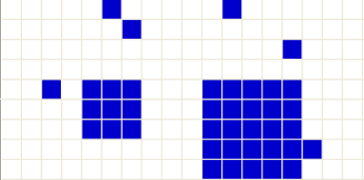
Figure 1. Layer 1 after simulation
Town Cell
City Cell
Figure 2. Layer 2 is not changed

Populated Cell
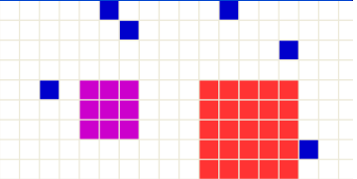
Figure 3. Layer 3 which Apply PopRule

